St. Cyprian’s Anglican Church
and Iona Presbyterian Church
1080 Finch Ave East, Toronto, Ontario
Telephone: 416–494–2442
Church office hours Tuesdays & Fridays 10:00 a.m. to 1:00 p.m.
Sunday Worship by Zoom and in person 10:30 a.m.

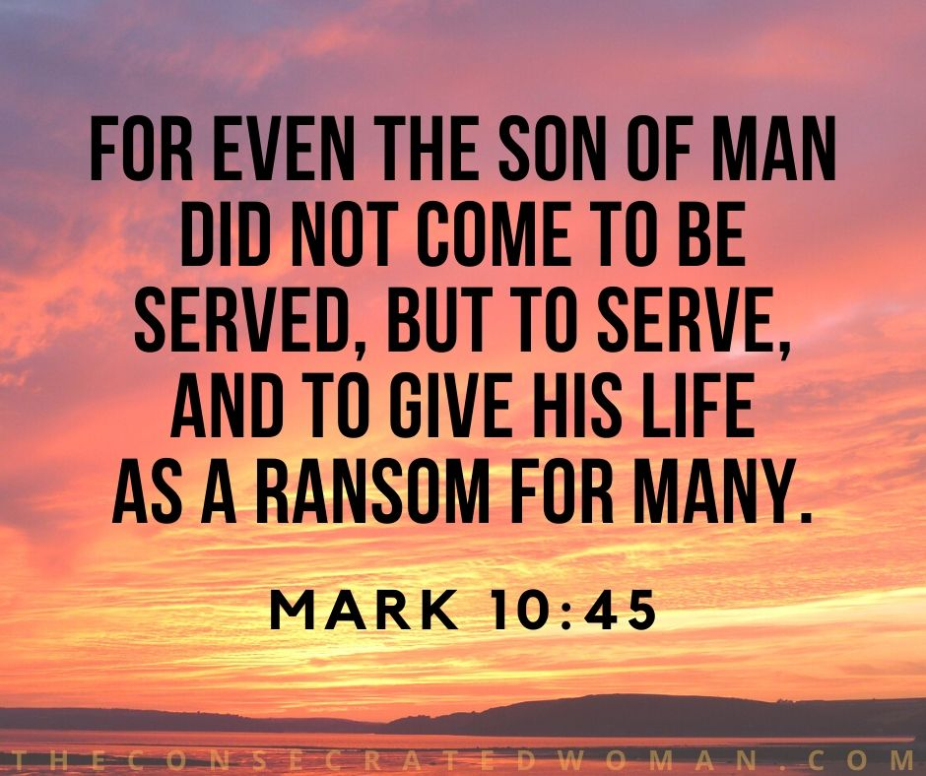
Pentecost 22,
October 20, 2024
Minister: Every member of the congregation
Priest-in-Charge: The Rev. Dr. John Oakes
Email: revdrjohnoakes@outlook.com
Phone: (647) 219-5754

Rector’s Warden: Carol Berger
People’s Warden: Stacey Leslie
Iona Elders: Marg Black, Dorine Bourque, Melissa Reid
Director of Music: Laura Hope
Office Administrator: Bob Williams

Zoom Link for Sunday Worship:

https://us02web.zoom.us/j/2897790104?pwd=WTVXeWtJZWV2RW9JVGJGOE5VUVB1dz09
Or call: 647 374 4685 or 647 558 0588
Meeting ID: 289 779 0104 Passcode: 432441

Land Acknowledgement
We acknowledge that we meet on the traditional lands of the Mississauga. We acknowledge this territory’s significance for the Indigenous peoples who lived, and continue to live, upon it and whose practices and spiritualities were tied to the land and continue to develop in relationship to the territory and its other inhabitants today.
Holy Communion (BAS)
Hymns are from Common Praise

Guest Presider and Preacher: Rev. Steve Shaw (St. Paul’s, Bloor St., Toronto)

Welcome

The Gathering of the Community

Opening Sentence: “The Son of man came also not to be served but to serve, and to give his life as a ransom for many” (Mark 10:45)
Processional Hymn #381: Praise My Soul, the King of Heaven

Presider: The grace of our Lord Jesus Christ and the love of God,
and the fellowship of the Holy Spirit, be with you all.
People: And also with you.

Presider: Almighty God,
All: To you all hearts are open, all desires known, and from you no secrets are hidden. Cleanse the thoughts of our hearts by the inspiration of your Holy Spirit, that we may perfectly love you, and worthily magnify your holy name; through Jesus Christ our Lord. Amen.

Kyrie Eleison
Presider: Lord, have mercy upon us.
People: Christ, have mercy upon us.
Presider: Lord, have mercy upon us.
The Collect of the Day
Presider: Let us pray.
Almighty and everliving God,
increase in us your gift of faith,
that forsaking what lies behind
and reaching out to what is before,
we may run the way of your commandments
and win the crown of everlasting joy;
through Jesus Christ our Lord,
who lives and reigns with you and the Holy Spirit,
one God, now and for ever. Amen.
The Proclamation of the Word

First Reading: Hebrews 5:1–10 Brenda Haddock

Reader: The first reading is taken from the fifth chapter of the
Epistle to the Hebrews, beginning at the first verse.
¹Every high priest is selected from among the people and is appointed to represent the people in matters related to God, to offer gifts and sacrifices for sins. ²He is able to deal gently with those who are ignorant and are going astray, since he himself is subject to weakness. ³This is why he has to offer sacrifices for his own sins, as well as for the sins of the people. ⁴And no one takes this honour on himself, but he receives it when called by God, just as Aaron was.
⁵In the same way, Christ did not take on himself the glory of becoming a high priest. But God said to him, “You are my Son; today I have become your Father.”
⁶And he says in another place, “You are a priest for ever, in the order of Melchizedek.”
⁷During the days of Jesus’ life on earth, he offered up prayers and petitions with fervent cries and tears to the one who could save him from death, and he was heard because of his reverent submission. ⁸Son though he was, he learned obedience from what he suffered ⁹and, once made perfect, he became the source of eternal salvation for all who obey him ¹⁰and was designated by God to be high priest in the order of Melchizedek.

Reader: The Word of the Lord.
All: Thanks be to God

Psalm 104:1–9, 24, 35c

Presider: 1. Bless the Lord, O my soul;
O Lord my God, how excellent is your greatness!
you are clothed with majesty and splendour.
People: 2. You wrap yourself with light as with a cloak
and spread out the heavens like a curtain.
Presider: 3. You lay the beams of your chambers in the waters above;
you make the clouds your chariot;
you ride on the wings of the wind.
People: 4. You make the winds your messengers
and flames of fire your servants.
Presider: 5. You have set the earth upon its foundations,
so that it never shall move at any time.
People: 6. You covered it with the deep as with a mantle;
the waters stood higher than the mountains.
Presider: 7. At your rebuke they fled;
at the voice of your thunder they hastened away.
People: 8. They went up into the hills and down to the valleys beneath,
to the places you had appointed for them.
Presider: 9. You set the limits that they should not pass;
they shall not again cover the earth.
People: 24. People go forth to their work
and to their labour until the evening.
Presider: 37. Bless the Lord, O my soul.
Hallelujah!
Let us pray. O God of eternal light, heaven and earth are the work of your hands, and all creation sings your praise and beauty. As in the beginning, by your Spirit, you gave life and order to all that is,
so by the same Spirit redeem us and all things, through Christ
our Lord. Amen.

Gradual Hymn #712: Alleluia (Chorus x2)
Gospel Reading: Mark 10:35–45 - Hanson Lam

Reader: The Lord be with you.
All: And also with you.
Reader: The Holy Gospel of our Lord Jesus Christ according to the tenth chapter of Saint Mark, beginning at the thirty-fifth verse.
All: Glory to you, Lord Jesus Christ.
³⁵Then James and John, the sons of Zebedee, came to him. “Teacher,” they said, “we want you to do for us whatever we ask.” ³⁶”What do you want me to do for you?” he asked. ³⁷They replied, “Let one of us sit at your right and the other at your left in your glory.” ³⁸”You don’t know what you are asking,” Jesus said. ”Can you drink the cup I drink or be baptized with the baptism I am baptized with?” ³⁹”We can,” they answered. Jesus said to them, ”You will drink the cup I drink and be baptized with the baptism I am baptized with, ⁴⁰but to sit at my right or left is not for me to grant. These places belong to those for whom they have been prepared.” ⁴¹When the ten heard about this, they became indignant with James and John. ⁴²Jesus called them together and said, “You know that those who are regarded as rulers of the Gentiles lord it over them, and their high officials exercise authority over them. ⁴³Not so with you. Instead, whoever wants to become great among you must be your servant, ⁴⁴and whoever wants to be first must be slave of all. ⁴⁵For even the Son of Man did not come to be served, but to serve, and to give his life as a ransom for many.”
Reader: The Gospel of Christ
All: Praise to you, Lord Jesus Christ.

Gradual Hymn #712: Alleluia (Chorus x2)

Sermon: Rev. Steve Shaw

Duet: "O Lovely Peace" (from "Judas Maccabaeus" by G. F. Handel)
sung by Brenda Haddock and Sandra Baker

The Apostles’ Creed

Presider: Let us confess the faith of our baptism, as we say:

Do you believe in God the Father?
All: I believe in God, The Father almighty,
creator of heaven and earth.
Presider: Do you believe in Jesus Christ, the Son of God?
All: I believe in Jesus Christ, his only Son, our Lord.
He was conceived by the power of the Holy Spirit
and born of the Virgin Mary. He suffered under Pontius Pilate, was crucified, died, and was buried. He descended to the dead. On the third day he rose again. He ascended into heaven, and is seated at the right hand of the Father. He will come again to judge the living and the dead.
Presider: Do you believe in God the Holy Spirit?
All: I believe in God the Holy Spirit, the holy catholic Church,
the communion of saints, the forgiveness of sins,
the resurrection of the body, and the life everlasting. Amen.

Prayers of the People

Intercessor: In peace, we pray to you, Lord God.
Silence
For all people in their daily life and work;
People: For our families, friends, and neighbours, and for all those
who are alone.
Intercessor: For this community, our country, and the world, and especially for those nations riven by war and conflict, including Israel, Palestine, Ukraine and Russia;
People: For all who work for justice, freedom, and peace.
Intercessor: For the just and proper use of your creation;
People: For the victims of hunger, fear, injustice, and oppression.
Intercessor: For all who are in danger, sorrow, sickness, especially Diane, Edna, Freda, Judy, Sadie, John, and all others whom we now name.

The people may add their own petitions.

For those in any kind of trouble;
People: For those who minister to the sick, the friendless, and the
needy.
Intercessor: For the peace and unity of the Church of God;
People: For all who proclaim the gospel, and all who seek the truth.
Intercessor: For Andrew, Kevin and Riscylla our bishops, for John our priest and pastor, for Alex, our interim moderator, for our elders and wardens, and for all other ministers;
People: For all who serve God in his Church.
Intercessor: For our own needs and those of others, especially those which we now remember before you.

The people may add their own petitions.

Hear us, Lord;
People: For your mercy is great.
Intercessor: We thank you, Lord, for all the blessings of this life.

The people may add their own thanksgivings.

We will exalt you, O God our king;
People: And praise your name for ever and ever.
Intercessor: We remember all who have died in the peace of Christ,
and those whose faith is known to you alone.

The people may add their own petitions.

Lord, let your loving kindness be upon them;
People: Who put their trust in you.
Intercessor: We pray to you also for the forgiveness of our sins.

Silence.

All: Have mercy upon us, most merciful Father; In your compassion, forgive us our sins, known and unknown, things done and left undone; and so uphold us by your Spirit that we may live and serve you in newness of life, to the honour and glory of your name; through Jesus Christ our Lord. Amen.

Absolution

Presider: Almighty God, have mercy upon you. Pardon and deliver you from
all your sins, confirm and strengthen you in all goodness, and keep
you in eternal life through Jesus Christ our Lord, Amen.
The Peace
Presider: The peace of the Lord be always with you.
All: And also, with you.

Offertory Hymn #415: All Things Bright and Beautiful

Prayer over the Gifts

Presider: Eternal God, your word inspires our faith. May we who offer you our praise trust you in all things. We ask this in the name of Jesus Christ the Lord.
All: Amen.

The Celebration of the Eucharist
Communion Prayer

Presider: The Lord be with you.
People: And also with you.
Presider: Lift up your hearts.
People: We lift them to the Lord.
Presider: Let us give thanks to the Lord our God.
People: It is right to give our thanks and praise.
Presider: It is indeed right, our duty and joy, that we should always and everywhere give thanks to you, O Lord, holy Father, mighty Creator, and eternal God. Therefore with angels and archangels, and with the whole company of heaven, we praise and magnify your glorious name, evermore praising you, and singing:
All (sung):
(#735) Holy, holy, holy Lord, God of power and might,
Holy, holy, holy Lord, God of power and might,
heaven and earth are full, full of your glory.
Hosanna in the highest. Hosanna in the highest.
Blessed is he who comes in the name of the Lord.
Hosanna in the highest. Hosanna in the highest.

Presider: Almighty God, our heavenly Father, in your tender mercy you gave
your only Son Jesus Christ to suffer death upon the cross for our redemption. He made there, by his once and for all offering of himself, a full, perfect and sufficient sacrifice, atonement and satisfaction for the sins of the whole world. He instituted and in his holy gospel commands us to continue a perpetual memorial of his precious death until he comes again. Hear us, O merciful Father, we humbly pray, and grant that we who receive this bread and wine according to your Son Jesus Christ’s holy institution, in remembrance of his death and passion, may be partakers of his most blessed body and blood. On the night that Jesus was betrayed he took bread and when he had given thanks, he broke it and gave it to his disciples, saying: “Take, eat this is my body which is given for you. Do this in remembrance of me.” In the same way, after supper, he took the cup; and when he had given thanks, he gave it to them, saying: “Drink this, all of you, this is my blood of the new covenant,which is shed for you and for many for the forgiveness of sins. Do this, as often as you drink it, in remembrance of me. Amen.
(The above is a modern translation from the BCP Communion Prayer)

The Lord’s Prayer
Presider: And now, as our Saviour Christ has taught us, we are bold to say:
All: Our Father, who art in heaven. Hallowed be thy name, thy Kingdom come, thy will be done on earth, as it is in heaven. Give us this day our daily bread. And forgive us our trespasses, as we forgive those who trespass against us. And lead us not into temptation, but deliver us from evil. For thine is the kingdom, the power and the glory, for ever and ever, Amen.

Breaking of the Bread
Presider: “I am the bread of life,” says the Lord. “Whoever comes to me will never be hungry; whoever believes in me will never thirst.”
All: Taste and see that the Lord is good;
happy are they who trust in him!

Presider: The gifts of God for the People of God.
People: Thanks be to God.

All (#745) (sung):
Lamb of God, you take away the sins of the world:
have mercy on us.
Lamb of God, you take away the sins of the world:
have mercy on us.
Lamb of God, you take away the sins of the world:
grant us peace. Grant us peace.

Communion: All who know Jesus Christ as their Lord and Saviour are welcome to receive Communion. You may choose between the common or an individual cup. If you would rather not receive either, simply push out your hand. If would like to receive a blessing, please cross your arms when you approach the Communion station.

Communion Hymn: The Servant King (by Graham Kendrick)
From heav'n You came helpless babe
Enter'd our world Your glory veil'd
Not to be served but to serve
And give Your life that we might live

Chorus
This is our God the Servant King
He calls us now to follow Him
To bring our lives as a daily offering
Of worship to the Servant King

There in the garden of tears
My heavy load He chose to bear
His heart with sorrow was torn
Yet not my will but Yours He said/ Chorus

Come see His hands and His feet
The scars that speak of sacrifice
Hands that flung stars into space
To cruel nails Surrendered / Chorus

So let us learn how to serve
And in our lives enthrone Him
Each other's needs to prefer
For it is Christ we're serving / Chorus

CCLI Song # 78897
Graham Kendrick © 1983 Thankyou Music For use solely with the SongSelect® Terms of Use. All rights reserved. www.ccli.com CCLI License # 22158807

Prayer after Communion
Presider: God of peace, you have nourished us in this sacrament with the body and blood of Christ. May we who have taken holy things
keep faith in our hearts and lives, in the name of Jesus Christ the Lord.
All: Amen.

Presider: Glory to God.
All: Whose power working in us, can do infinitely more than we can ask or imagine. Glory to God from generation to generation. In the church and in Christ Jesus forever and ever, Amen.

Announcements
Blessing

Presider: The peace of God, which passes all understanding. Keep your hearts and minds in the knowledge and love of God and of his son Jesus Christ our Lord. The blessings of God Almighty, the Father, the son and the Holy Spirit be among you and remain with you always. Amen.

Recessional Hymn #423: How Great Thou Art

Dismissal

Presider: Alleluia! Let us go in peace to love and serve the Lord.
People: Thanks be to God. Alleluia!

ANNOUNCEMENTS
Welcome!

Welcome to St. Cyprian’s and Iona, as we continue our combined worship and ministry at 10:30 a.m. on Sundays. After today’s service, we invite everyone to join a joint fellowship time together in the Iona space.

Sunday Bible Study

The Sunday Bible Study continues today at noon in the Fellowship Room. Rev. John is helping facilitate a new study on 1 Corinthians, using a study guide by N. T. Wright. All are welcome!

Wednesday Noon Meditation

The Wednesday meditation with David Rudd and others meets at 12 noon. It is 20 minutes long and a helpful way to nurture your faith through the practice of silent prayer.

https://us02web.zoom.us/j/9321564941?pwd=QmhLdDZ6ekQ2a1FLMmRWK2tXU0F0Zz09
Meeting ID: 932 156 4941 Passcode: 1080

Emergency Pastoral Care for St. Cyprian’s

In the event that emergency pastoral care is needed between now and November 17, please feel free to contact the former Incumbent, Canon Victor Li (416- 617-4837), before October 29, or Rev. Sherri Golisky (416–880–4211) of St. Matthew’s, Oriole after that.

Choir

Choir holds weekly rehearsals on Fridays at 1:00–2:30 p.m. If you are interested in joining, please come out. You will be welcomed warmly. For more information, please speak to Laura Hope, Bob Williams or one of our choir members.

Friday Zoom Bible Study

Rev. John’s weekly Zoom Bible Study continues on Friday at 7:00 p.m. We’ll be working on 1 Corinthians, with a study guide by N. T. Wright. All are welcome!

The link for the meetings is: https://us02web.zoom.us/j/8517044556?omn=87394869005

You can also call in by phone on 647-374-4685 or 647-558-0588
Meeting ID: 851 704 45

Ministry Opportunities

There are ministry opportunities in a number of different areas, for which volunteers are welcome. To help, please contact one of the St. Cyprian’s wardens or Iona elders.

Happy Birthdays

Rod Hudson Oct 20

Happy birthday, Happy birthday, God loves you.
Happy birthday and may all your dreams come true.
When you blow out the candles, one light stays aglow
It’s the love light of our Lord for all to know.

